`Asia-China-Dragon-Long-龍-rc

The symbol of the dragon龍 or Lóng originated in the East Asian Neolithic where its depiction is found in several cultures.

***Xinglongwa and Zhaobaogou ; (c. 6000-4500 BC)***

Early Neolithic cultures in the Chifeng area--the Xinglongwa and Zhaobaogou cultures--were identified during the 1980�s (Xu 1989).  To date, very few habitation and burial sites of these periods have been excavated (Aohan 1991; Neimenggu 1994; Zhongguo 1985; Zhongguo 1987; Zhongguo 1998b; Zhu 1997).  These excavations yielded the earliest evidence in the area known so far for permanent habitation in villages, ceramic production, and the domestication and cultivation of plants and animals.  The small number of sites so far identified from these cultures and the limited area of excavations permits only tentative hypotheses about the way of life in this important period of transition to agriculture.   
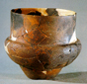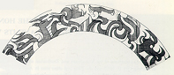Results from work to date indicate that systematic survey locates larger quantities of these scarce remains than survey methodologies that have been applied previously in the region.  So far we have recovered Xinglongwa ceramics in 16 different collection units in 14 spatially discrete small sites and Zhaobaogou ceramics in 28 collection units in 22 spatially discreet small sites.  The largest of these sites covers less than 3 ha.  These are presumably the remains of small economically self-sufficient egalitarian villages.  Further survey will be required to determine whether this occupation is relatively evenly spread throughout the region or tends to concentrate in certain sectors based on resource distribution or other factors.  Further site excavation and comparative study of features and artifact assemblages at the household scale will be required to delineate possible patterns of social or economic differentiation, productive specialization, etc.  Faunal and botanical remains reported to date demonstrate the presence of domesticated species, but quantitative study will be required to evaluate their relative importance as well as that of wild plants and animals and thus the completeness of reliance on agriculture and herding.

**The Xinglongwa Neolithic Culture**

The Xinglongwa type site in Aohan Banner, Inner Mongolia Autonomous Region that was excavated in 1983. The culture has a wide coverage that stretches to Xunhe in the west, Yiwulu Mountain in the east, to Wuerjimulun River in the north and to the northern coast of Bohai Sea in the south. Xinglongwa Site covers 20,000 square meters. The excavations yielded the earliest evidence in the area known so far for permanent habitation in villages, ceramic production, and the domestication and cultivation of plants and animals.

So far Xinglongwa ceramics in 16 different collection units in 14 spatially discrete small sites. The largest of these sites covers less than 3 hectares. These are presumably the remains of small economically self-sufficient egalitarian villages. Among these ceramics is a depiction of a fish dragon.

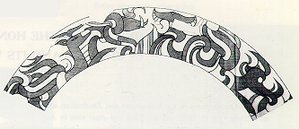

Fish dragon ceramic motif from Xinglongwa after http://www.pitt.edu/~chifeng/text.html.

Other unearthed relics include bone and stone artifacts, and jade. (http://www.chinaculture.org/gb/en\_artqa/2003-09/24/content\_39089.htm).

|  |
| --- |
|  |

The relics of Xinglongwa Culture are located at a tableland 1.5 kilometers to the southeast of Xinglongwa Village of Baoguotu Township, Aohan Banner, Chifeng, Inner Mongolia. The six rounds of excavations at Xinglongwa relics have discovered ruins of 170 houses and more than 30 graves, which took the lead in China in revealing all the traces of habitation, including ditches, ruins of houses and cave dwellings of the people of a pre-historic tribe.

The evolution of the habitation at Xinglongwa goes through three stages. Houses of the first stage are comparatively spacious, distributed in lines from the northeast to the southeast and surrounded by elliptical ditches. Houses of the second stage follow their predecessors in arrangement but with smaller areas; houses of the third stage are disorderly and more densely arranged with still smaller areas, indicating the considerable prosperity of the tribes of Xinglongwa.

The graves of Xinglongwa relics are an essential component of Xinglongwa Culture, and the number and location of these graves suggest that they are related to the sacrificial activities of the people of that time. In one of the graves, we can find that the dead was buried side by side with two pigs, one male and the other female, which leads to our assumption that due to his social status and extraordinary cause of death, the dead was taken by his fellow tribesmen as the object of worship and sacrificial rites so that they could be blessed by certain kind of supernatural power. The pigs buried alongside the dead indicate that the offering of sacrifices to ancestors was combined with those to the preys, and the offering of sacrifice by the inhabitants of Xinglongwa to the spirit of pig is considered to be of the significance of totem worship. The large numbers of bones of deer, pigs and other animals unearthed at the ruins of houses and among the funerary subjects is another proof to the fact that hunting economy was in the dominant position in people's life at that time.

The dozens of jade articles unearthed at Xinglongwa site shows that the people of Xinglongwa were aware of the selection of materials-most of the artifacts were made from pale green, yellowish green, milky white or light white materials, and that they had gained knowledge of polishing and boring. As the earliest genuine jade articles known to us in China so far, the artifacts unearthed at Xinglongwa site have marked the completion of the division of labor of the society, shifted the time of the use of ground genuine jade articles in China to the middle of Neolithic Age as far away as 8,000 years ago, and provided a direct origin for the jade articles of Hongshan Culture.

|  |
| --- |
|  |

The ceramics unearthed at Xinglongwa are notable as having a fish-dragon motif. The ceramics all have a sand temper, are heavy and fired at a low temperature, with grayish brown or yellowish brown exteriors and dark gray interiors. The decorative stripes outside are mostly pressed ones in the patterns of horizontal "^", "Z", woven mats and grids. All the potteries are made bu the coil method without the wheel. Notably among these ceramics is a Fish Dragon motif (http://www.china.org.cn/english/China/217746.htm).

The stoneware found in the relics of Xinglongwa consists typically of chipped stone hoes and axe-shaped implements.

Kernels of juglans mandshurica, an arbor usually found in mixed forests of deciduous broad leaf trees and coniferous trees, which are typical in temperate zones, were unearthed at the earlier relics of Xinglongwa, indicating the warm and humid climate that is in sharp contrast to the arid climate of grassland and desert.

Xinglongwa Culture is one of the three major cultural systems of northern China, the discovery of which demonstrates that the culture of Neolithic Age in Inner Mongolia is of a long history. As the origin of Hongshan Culture, Xinglongwa Culture plays a significant role in revealing the characteristic aboriginality and continuity of the Neolithic cultures at the eastern part of the Great Wall and helps determine the historic position of the culture in interacting with the Neolithic cultures in the Huanghe River valley and in promoting the progress of the culture of the whole northeastern China.

The **Zhaobaogou culture** (趙宝溝文化) (5400–4500 BCE)[[1]](http://en.wikipedia.org/wiki/Zhaobaogou_culture" \l "cite_note-1) was a [Neolithic](http://en.wikipedia.org/wiki/Neolithic) culture in northeast [China](http://en.wikipedia.org/wiki/China), found primarily in the [Luan River](http://en.wikipedia.org/wiki/Luan_River) valley in [Inner Mongolia](http://en.wikipedia.org/wiki/Inner_Mongolia) and northern [Hebei](http://en.wikipedia.org/wiki/Hebei). The culture produced sand-tempered, incised [pottery](http://en.wikipedia.org/wiki/Pottery) vessels with geometric and zoomorphic designs. The culture also produced stone and clay human figurines.

The [type site](http://en.wikipedia.org/wiki/Type_site) at Zhaobaogou, excavated in 1986, was discovered in [Aohan Banner](http://en.wikipedia.org/wiki/Aohan_Banner), [Chifeng](http://en.wikipedia.org/wiki/Chifeng), Inner Mongolia. The site covers an area of around 90,000 m2.[[2]](http://en.wikipedia.org/wiki/Zhaobaogou_culture" \l "cite_note-2)

* 1. **[^](http://en.wikipedia.org/wiki/Zhaobaogou_culture" \l "cite_ref-1)** *Archaeology of Asia*, p. 129
  2. **[Jump up](http://en.wikipedia.org/wiki/Zhaobaogou_culture" \l "cite_ref-2) ^** *The Archaeology of Northeast China: Beyond the Great Wall*, p. 54

## References

* Allan, Sarah (ed), *The Formation of Chinese Civilization: An Archaeological Perspective*, [ISBN 0-300-09382-9](http://en.wikipedia.org/wiki/Special:BookSources/0300093829)
* Nelson, Sarah Milledge (ed), *The Archaeology of Northeast China: Beyond the Great Wall*, [ISBN 0-415-11755-0](http://en.wikipedia.org/wiki/Special:BookSources/0415117550)
* Stark, Miriam T. (ed), *Archaeology of Asia*, [ISBN 1-4051-0213-6](http://en.wikipedia.org/wiki/Special:BookSources/1405102136)

The Zhaobaogou Culture succeeded the Xinglongwa Culture and originated in the middle and later period of the Xinglongwa Culture. The ancient cultural relics of the Zhaobaogou Culture are located in Aohan Banner, Chifeng City of Inner Mongolia.

|  |
| --- |
|  |

The site cover an area of about 90 000 m2. The houses at the site are either square or of trapezium-shaped. They are semi-basements and arranged in rows. Compared to the Xinglongwa Culture, the settlements of the Zhaobaogou Culture were much larger. However, the two had much in common, for example, the arrangement of houses in rows and the different sizes of the houses. This affinity was attributable to shared regions, close technological levels, cultural heritage and other factors. However, the main factor was the close economic mode. The characteristic of Zhaobaogou's stoneware was the co-existence of ground stoneware and fine stoneware. The tools used to produce stoneware were mainly sharp-curved stone spades, flat stone axes, curve-edged stone knives, ground plates and ground sticks. It can be noticed that the Zhaobaogou Culture was more developed than the Xinglongwa Culture in terms of production tools.

Pottery unearthed at the Zhaobaogou Culture site was mainly tan or mahogany with sand inclusions. They were all hand-made and simple, but more diversified in their shapes than those of the Xinglongwa Culture.

Zun (a kind of ancient vessels for wine)-shaped ware is most typical of the Zhaobaogou Culture. It has small or straight mouths, long and thick necks, and flat and round bellies, with slightly curved bottoms. When it was polished, geometrical shapes were inscribed on it. Even the patterns of animals were cut into the bellies. Animals' heads were treated in both realistic and exaggerated ways to reflect the most noticeable part of the animal's organs. The pig-dragons, flying deer and magic birds patterns discovered at Xiaoshan made today's people marvel at the intricate designs. The zun with a pattern of a pig's head and a snake's body was the earliest example of dragon worship by the Chinese people, which shows that Inner Mongolia was also one of the important cradles of Chinese dragon worship. Pig-dragon, phoenix, flying deer and other zun-shaped ware showed that society was polarized to great extent at that time. These earliest "artistic divine works" were 1,000 years older than the 6,000-year-old Dragon-Tiger Heap Sculpture at Xishuipo, Puyang, Henan Province.

No venues for sacrifices were found so far at the Zhaobaobou Culture sites. Therefore, the activities might have been carried out indoors. The zun-shaped ware was used during sacrificial activities for wishing successful hunts. This indicated that hunting was an important part of the life of the ancient Zhaobaogou people. Their religious ceremonies were mostly related to hunting. The ancient Xinglongwa people used the skulls of animals for sacrifices, while the ancient Zhaobaogou people used pottery with the images of animals they hunted.

The Zhaobaogou Culture was slightly younger than the Xinglongwa Culture, but older than the Hongshan Culture. It was one of the early cultures of the Neolithic Age. The three cultures were obviously in succession. The Zhaobaogou Culture and the Hongshan Culture shared many common aspects and the former was more developed than the Hongshan Culture. For example, the pig-dragon and a jade dragon with a pig's head and a snake's body must have a close connection and the pottery of both cultures have Z shapes printed on them. Therefore, the Zhaobaogou Culture should be an ancient culture that exerted a great influence on the development of the Hongshan Culture.

***Hongshan (c. 4500-3000 BC) and Xiaoheyan (c. 3000-2200 BC)***   
The Hongshan culture has attracted much attention.  However, in spite of--and maybe even because of--the zeal with which these ritualistic expressions are being studied, the more mundane aspects of the Hongshan culture have been largely neglected.  Only meager information on domestic sites of the Hongshan has been published and almost nothing at all is known about internal site structure and about settlement patterns.   
The ritual structures, the elaborate jade sculptures, and the concentration of offerings in the burials of a few individuals that have been reported for Hongshan sites are highly suggestive of the kinds of societies to which the term "chiefdom" or some similar label is often applied (e.g. Drennan 1995; Earle 1987, 1997).  In the survey area to date, Hongshan ceramics were encountered in 203 different collection units, forming some 129 spatially discrete sites, suggesting quite substantial population growth for this period.  Altogether 1527 Hongshan sherds were recovered, compared to only 309 for Xinlongwa and Zhaobaogou combined, reinforcing the impression of considerable increase in population.  (These latter two together account for about the same amount of time as Hongshan does.)  Some sites continue to be quite tiny, as before, but one was as large as 11 ha, and there is a tendency for larger sites to group together, quite possibly representing communities within which inter-settlement interaction had taken on greater importance.  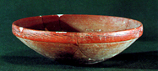The social, political, ritual, and/or economic aspects of such interaction remain to be explored, but it may represent the initial webs of regional relationships upon which complex societies are based.  Completion of survey over a larger area will be required to delineate these patterns comprehensively, to see how they emerge from those of the previous period and give way, in turn, to later ones. Identifiable Xiaoheyan ceramics are relatively rare, 174 sherds found in 31 collections in 28 discreet sites, suggesting that these ceramics transitional between Hongshan and Lower Xiajiadian may not represent an entirely distinct period in their own right.  Further stratigraphic chronological work will be required to clear up this question.

***Yangshao culture***

a dragon in a mussel shell mosaic is preserved together with that of a tiger in a Yangshao Culture (shaman's ?) burial in Xishuipo at Puyang, Henan Province, ca. 3000 BCE where the two figures are in their correct positions according to the cosmology of 2500 years later.

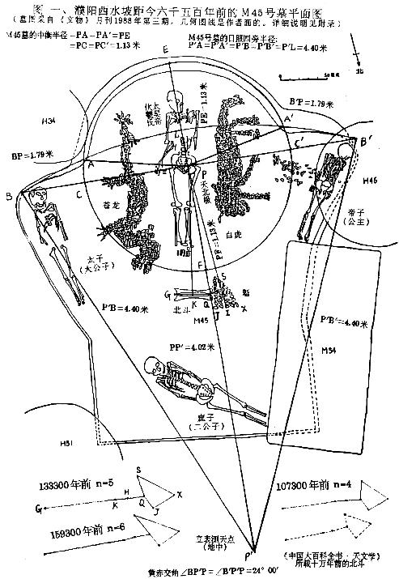

Sketch of the design and arrangement of Tomb M45 at Xishuipo, Puyang, Henan Province:. Mussel mosaic dragon funerary figure (蚌塑龙虎陪葬图), left of skeleton, and mussel mosaic tiger funerary figure (蚌塑虎陪葬图), right of skeleton. Orientation: line P'-E, mag. N; B-B', W-E. After duanbangning.blog.163, retrieved Nov. 1, 2013.

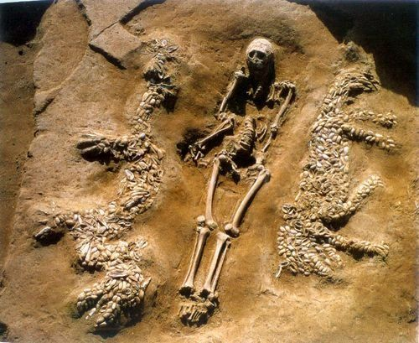

The upper portion of tomb M45 showing the three-dimensional shell mosaic of the dragon and tiger and their relationship to the deceased. Note that eyes for both the dragon and the tiger are carefully indicated. For the dragon the head is formed of shells with their external convex surfaces carefully placed facing the viewer, but one shell for the eye of the dragon is turned with the concave side facing upwards. For the tiger four shells are placed in a diamond arrangement for the eye. In both the dragon and the tiger four claws are indicated but those for the dragon are three times longer tha those for the tiger.After http://henan.sinaimg.cn/2013/0507/U8778P827DT20130507080024.jpg.

In 1987, an intact tomb (no. M45) was excavated at Xishuipo, a Neolithic site in Puyang, Henan Province. It was initially C-14 dated to ca. 5300 BCE but when calibrated with dendrochronology the tomb was found to have been built in the Yangshao cultural period about 4500 BCE.) The alignment of the mosaics in the tomb suggests they havecosmological and astronomical significance. For this reason, the tomb is assumed to be that of a king or a 'shaman, ' since the owner was considered one of the élite, perhaps a spiritual leader).

The outline of the grave is in the shape of a keyhole, a form of entombment structure that was to figure in Korean and Japanese Koguryo graves. The belief was that heaven was composed of 6 concentric circles divided by 7 curves established how the crown shape is obtained. The adult skeleton is positioned in the centre of the unusually large cardinally oriented grave. The adult skeleton is laid out in such a way that the southern face above the head was round while the northern face at the foot of the body was square. This conforms to the symbolism of Chinese cosmology which held that Heaven was round and Earth was square. A number of astral forms keep the skeleton company. The body of a tall adult male is flanked by two carefully laid out mosaics formed from white mussel/clam shells, a tiger design to the right (west) and a dragon design to the left (east). These mosaics are believed to be representations of 2 of the 4 super constellations (the Azure Dragon and the White Tiger). In the same tomb there is also a representation of the Big Dipper (in the form of a triangle, as it would have been far in the past), also created from white mussel/clam shells. The Big Dipper is pointing toward the head of the dragon. Two human bones are placed amongst the array of symbols. Three funerary human skeletons were also found in the tomb. The burial was accompanied by the bodies of 3 young children. Clam shell mosaics were also found in two nearby caches. Another key claim is: The funerary skeleton on the north side of the M45 tomb was a young boy’s skeleton (estimated to be 15 years old when he died). At the estimated time of the burial his head was pointed in the direction of the sunrise on the Winter Solstice.

"On the Date of Astronomical Phenomena in Tomb No.45 at Xishuipo, Puyang, Henan." by Duan Bang – Ning. Abstract: "On the basis of the proper motion of the seven stars of Big Dipper and ecliptic precession in astronomy, through the numerical analysis and comparison with the star maps by microcomputer, we would arrive at such a conclusion. The date of astronomical phenomena in the tomb No.45 at Xishuipo Puyang, Henan is about 133000±1000 years ago. The sun, at that time, was setting beyond the western horizon during Spring Equinox. The latest limit of the date of this astronomical phenomena is 100,000 years ago; and its earliest limit is 160,000 years ago. The ecliptic coordinates of North Pole were at longitude 136° by celestial latitude 66.5°, and that of Spring Equinox Point were at longitude 46° by latitude 0°. The epoch of them is 2000.0 A.C. Of course, the triangle arranged with clam shells, a copy of the four stars in the bowl of ancient Big Dipper, is certainly the record of earliest astronomical observation. It is also the earliest record of scientific observation in the history of mankind." (Note: This statement in relation to the dates claimed obviously need to be treated with caution.)

The mosaics in tomb M45 are of similar design to the designs found in the Zenghouyi tomb in Hubei Province, which was built circa 1000 BCE. The designs on the cover of a lacquer box in the Zenghouyi tomb are the earliest written records of the 28 lunar lodges (divisions of the sky) in China. The clam shell mosaics in tomb M45 may represent the constellations (be evidence for a celestial map) and be evidence for a calendar.

See the informed discussion in: Pankenier, David. (2011). "The cosmic center in Early China and its archaic resonances." In: Ruggles, Clive. (Editor). Archaeoastronomy and Ethnoastronomy: Building Bridges between Cultures. (Pages 298-307). [Note: Proceedings of the International Astronomical Union, Volume 7, SymposiumS278 [Issue 278], ("Oxford IX" International Symposium on Archaeoastronomy).]

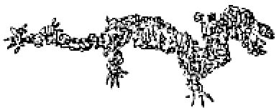

Additionally, other Neolithic Cultures also had their dragons.

Jade Pig-like Dragon unearthed from Nvshen Temple of Hongshan Culture in Niuheliang of Liaoning,

a Pottery Sherd with Dragon Pattern from Zhahai in Fuxin of Liaoning,

Dragon-shape Heap from Baihu Township in Huangmei of Hubei,

Jade Bracelet with Dragon Head from Liangzhu in Yuhang of Zhejiang. These archaeological discoveries reveal the East Asian dragon in its original ancient Neolithic context. But, what did it originally signify?

In Shang and Zhou Period, the pattern of dragon was mainly in jade and bronze. The body of dragon was generally like snake and the head was integrated with the features of other animals. Without feet or with one foot, the shape of dragon was mainly a simple curve like “S” or “C”. The simple and unsophisticated lines were usually combined with the pattern of clouds and lighting which was popular in that period.

In the Spring and Autumn and Warring States Period, the jade pendent with dragon pattern appeared. The dragon patterns were also found in silk paintings and brocades. In this period, the pattern of dragon had many complex forms with four or a group of dragons coiling together and making banded pattern. This pattern had perfect decorative effects and maintained a mascot style with profound messages.